MEMBERS OF THE BOARD | RIALTO UNIFIED SCHOOL DISTRICT
Mrs. Stephanie E. Lewis | 182 E. Walnut Ave
 | Rialto, CA 92376
Mrs. Nancy G. O'Kelley | Telephone: (909) 820-7700
Mr. Joseph W. Martinez
Mrs. Evelyn Dominguez | Cuauhtemoc Avila, Ed.D.
Mr. Edgar Montes | Superintendent
 | Dr. Patricia Chavez, Ed.D.
 | Lead Innovation Agent
PARENT and STUDENT NOTIFICATION

Rules Concerning Use of Loaned Computing Devices (i.e., Tablets, Laptops) and Related Accessories
Assigned to Students

Student Last Name:____________________ | Student First Name: _________________ | Date: ________________
Parent Last Name:____________________ | Parent First Name: _________________ | Date: ________________

I am being issued a Rialto Unified School District (RUSD) computing device and related accessories. I agree to keep it safe and well maintained. I will follow the guidelines for care of the device as explained below.

SECURITY

- I will know where my assigned device is at all times.
- I will never leave my assigned device unattended.

- I will never loan my assigned device to anyone.

- I realize that security devices have been installed on the assigned device that permit tracking and that usage will be monitored.

- I will, at all times, keep myself safe and will use the device only in areas where I can keep myself and the device safe.

(Student and Parent initial here)

CARE

- I will protect the screen from scratches.

- I will keep food and beverages away from my assigned device since they may cause damage to it.

- I will not mark, draw, write or place unapproved stickers on the device or case.

- I will not disassemble or attempt any repairs on any part of my assigned device. Doing so will void the device’s warranty.

- If damage occurs, including, but not limited to, scratches, cracks or dents, I will report the damage to the school administration within 24 hours or as soon as possible thereafter.
- In the case of theft or vandalism, I will file a police report and notify school administration within 24 hours or as soon as possible thereafter.

(Student and Parent initial here)

USAGE

- I will follow the RUSD Acceptable Use Policy (AUP) for use of RUSD computers and network systems.

- I will not reformat the device, tamper with its security settings, or change its operating system (e.g., iOS for Apple Devices).

- I will adhere to all applicable copyright and software license agreements that forbid downloading of media and software that has not been legally acquired.
- I will not engage in any harassment or acts of intimidation (cyber-bullying) in an attempt to harm other people using my assigned Device or any other electronic device.

(Student and Parent initial here)

RESPONSIBILITY

- I understand that my assigned device is subject to review by Technology Services, at any time and without notice, to review files and communications to maintain system integrity and ensure that uses are using the system responsibly. I further understand that the device remains the property of RUSD.
- I agree to return the device, related accessories and device case in good working condition (with the exception of normal wear and tear) immediately upon request by RUSD.
- I will return the assigned device to my school administrator (or designee) at the end of each school year. If I withdraw, am expelled, or terminate enrollment at my school for any reason, I will return the assigned device and accessories on the date of termination to the school’s administrator. I will not engage in any harassment or acts of intimidation (cyber-bullying) in an attempt to harm other people using my assigned Device or any other electronic device.

(Student and Parent initial here)
PARENT/GUARDIAN ACKNOWLEDGEMENT

(Devices Take Home)

Responsibility for Loaned Computing Devices Assigned to Students

This document informs you of your legal responsibility with regard to the device and its related accessories, which may include case, keyboard, cable and battery charger described below, that the Rialto Unified School District (“RUSD”) is loaning to your child.

RUSD may hold a family liable of any minor who willfully cuts, defaces, or otherwise injures any property of RUSD, or fails to return any property of RUSD upon demand of RUSD, for all damages caused by the minor. (See, Board Policy 6161.2, Damaged or Lost Instructional Materials, dated September 25, 2019 and Education Code 48904.) RUSD property includes the Loaned Equipment, which parents will be charged $650 for lost or broken devices. In lieu of the charge, up to 20 hours of community service may be completed.

Fee Schedule For Devices and Accessories
Replacement cost of laptop device | $650.00
Laptop power supply | $35.00
Laptop protective case | $16.00
Replacement cost of iPad devices | $250.00
iPad protective case | $21.00
iPad Charger | $20.00
Hotspot/Hotspot Charger | $30.00/$5.00

- I agree to the Security, Care, Usage and Responsibility conditions listed in the “Rules Concerning Use of Loaned Devices (i.e., Tablets or Laptops) Assigned to Students” (“Rules”), on the previous page. My child’s failure to abide by the Rules, thereby resulting in damage to or loss of the Device, may be considered a willful act for which I am liable, subject to due process procedures.

- The Loaned Equipment is, and will remain, the property of the Rialto Unified School District with the sole intended use by the student to whom it has been assigned.

- I further agree to abide by RUSD’s Responsible Use Policy (AUP) for use of loaned equipment and RUSD’s computer network.

CHOOSE AN OPTION BELOW BY CHECKING THE APPROPRIATE BOX

❐ OPTION 1 – “OPTING IN” TO TAKING DEVICE HOME – Yes, I want my student to take the device home.

󠆶 ❐ OPTION 2 – “OPTING OUT” TO TAKING DEVICE HOME – No, I do NOT want my child to take the device home. I understand that a device will be checked out to my child and that they are responsible for the device throughout the school day.

Hotspots are also available for students who do not have access to WiFi at home. Please contact your school site if you need a hotspot.
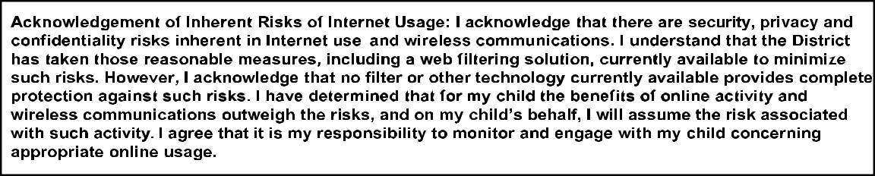

Student Name:
Student Signature: | Date:
Parent/Guardian Name:
Parent/Guardian Signature: | Date:

